Wednesday, April 27, 2022
7:00pm - 8:00pm (via Zoom)

Sustainability: Your changing attitudes and actions

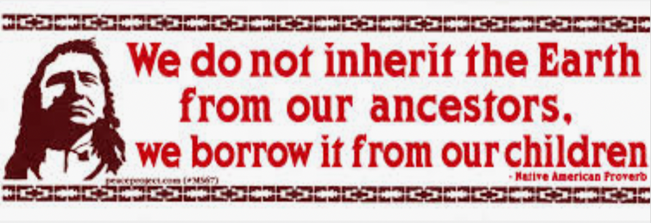

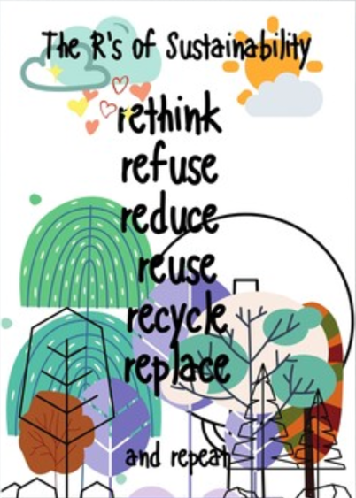 | 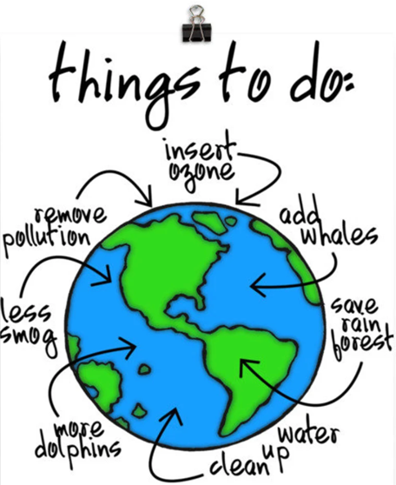

During breakout sessions, we will reflect on the following:

- When you hear the word Sustainable, what comes to mind for you?
- How have your attitudes about sustainability changed over the years?
- What are your pet peeves (actions of others that go against sustainability)
- Have you consciously changed your spending habits and/or investments to promote sustainability (electric car, bike, ESG investments, etc). Give examples.
- What are some easy things you’ve started doing that have reaped big rewards for yourself or your community?

Facilitator: WMD member and past President, Laurie Nardone
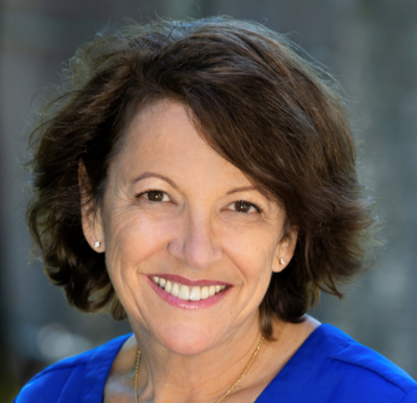
I have been a resident of Marin County since 1978 having moved here from the other end of the world…Rhode Island. I have two terrific sons, one living in Washington and the other local. It is probably the combination of living here in Marin, and having children, that has motivated me to take a deeper and longer look at what I do every day to try to make the world a better place for those who come after me.
I am a Certified Financial Planner™ specializing in working with people who measure their financial 'winning' by the satisfaction of enjoying their lifestyle and their financial confidence.

I am passionate about my family and friends, traveling around the world (or to baseball stadiums in the U.S.), providing financial education to all ages, listening / seeing / dancing to Bruce Springsteen and other bands, going to SF Giants games, hiking, and relaxing at the beach (my RI roots).
I feel honored and lucky to be a part of the Wonderful Marin Dialogue group and enjoyed my years being on the board and serving as a past President. I am also a member of the Financial Planning Association (FPA), and am on the board of the League of Women Voters Marin County.

Register in advance for this meeting [Registration Link here]:
After registering, you will receive a confirmation email containing information about joining the meeting. Contact Program Co-chairs Vanitha Sampath (vanitha.sampath@gmail.com) or Chantel Walker (Clwalker8899@gmail.com) any questions about this event or if you’re interested in facilitating a future Deeper Dialogue or have a topic idea for Deeper Dialogue.

